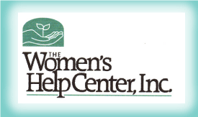

The Women’s Help Center, Inc.
2018 Annual Report

MISSION
~Striving to end domestic violence through empowerment, support and education~

94 Adults/68 children found refuge in our emergency safety shelter
1,474 shelter nights provided to adults/907 to children/youth

626 Primary Prevention Programs provided
Reaching 20,161 persons

161 Education/Awareness programs were provided
178 Events
Reaching a total of 5,405 people
Group Counseling Hours
Adult- 575
Children/Youth- 44

969 Crisis/Hotlines Calls Received

The Women’s Help Center, Inc. hosted a free-of-charge Near-Fatal Strangulation Training May 31, 2018. Presented by Lt. Dan Rincon of Alliance for Hope International For first responders, judges, prosecutors, and advocates of Cambria and Somerset Counties

WHC went to The Training Institute on Strangulation Prevention to become Certified through their 4-day Advanced Course on Strangulation Prevention and won first place for most dedicated team

Provided Holiday Sponsorships to 32 families

Conducted two strategic planning meetings including staff, board, and community members

Provides Group Counseling to many organizations in Cambria and Somerset County inlcuding the Cambria County prison, Community Action Somerset, an emergency shelters for at risk youth, and a day school for children with mental/behavioral issues
Expanded Trauma Informed Yoga Groups

